VR MATHEMATICAL CONCEPT VISUALIZATION

USER MANUAL

# Table of Contents

Table of Contents 2

Introduction 3

MATLAB Converter GUI 4

Steps 4

VR Application 5

Steps 5

Controller 6

# Introduction

The Mathematical Concept Visualization tool was designed as proof of concept tool to convert a MATLAB 3D figure file into an object file, which then could be ingested into a VR application to be viewed in 3D space. Attempting to visualize a 3D function on a 2D screen is inherently difficult. This tool allows a user to better visualize and understand the 3D function created in MATLAB by providing a 3D space to view it, which includes depth of perception, and reaction to natural movement through the headset.

As an addition to the project, and to fulfill requirements set by the Swanson School of Engineering Electrical and Computer Engineering Department senior design course, there is also a fabricated controller which communicates directly with the VR application. This controller is designed for fine-tuned manipulation of the VR 3D function object. This manipulation includes spacial location and 3 axis rotation of the object.

This visualization tool manifests itself into two processes: conversion and visualization. Conversion is done through a MATLAB add-on graphical user interface (GUI), while viewing is done through a VR application on Unity. This user manual explains to the user how to execute both processes in order to effectively use this tool.

# MATLAB Converter GUI

This assumes you, the user, have already created a figure file from MATLAB. The figure file must be a 3D function. This manual also assumes the user has access to the GUI, and does not detail how to download it off MATLAB central file exchange.

## Steps

1. Open the VR Mathematical Concept Visualization GUI in MATLAB.
2. Browse your filesystem for the 3D function figure file created and saved from MATLAB using the first button from the top.
3. Browse the location of the folder named VRMCV on your desktop using the second browse button from the top of the GUI. If there is no folder on the desktop named that, create a folder named VRMCV on the desktop.
4. Once both files are selected, click the “convert” button on the GUI. The MATLAB console should print “SUCCESS” if the conversion was successful. If not, please make sure that the figure file is indeed a “.fig” saved file from a 3D function in MATLAB.
5. Close the GUI.

# VR Application

This assumes you have the VR Mathematical Concept Visualization (VRMCV) project on Unity, and that the converted figure file and associated CSV file is placed in the VRMCV folder on the computer’s desktop.

## Steps

1. Plug the fabricated controller into a USB port on the computer (optional).
2. Open the project in Unity.
3. Press the play button at the top of the screen while the MainMenu scene is selected.
4. From the start menu, press “Start Viewing” to open the scene with the object, or press “Exit” to close the application from within the headset.
5. If you chose to open the scene, the object will be viewable.
6. Walk about the object and manipulate its position within the 3D space with the fabricated controller. The buttons and their descriptions can be found in the “Controller” section (optional).

# Controller

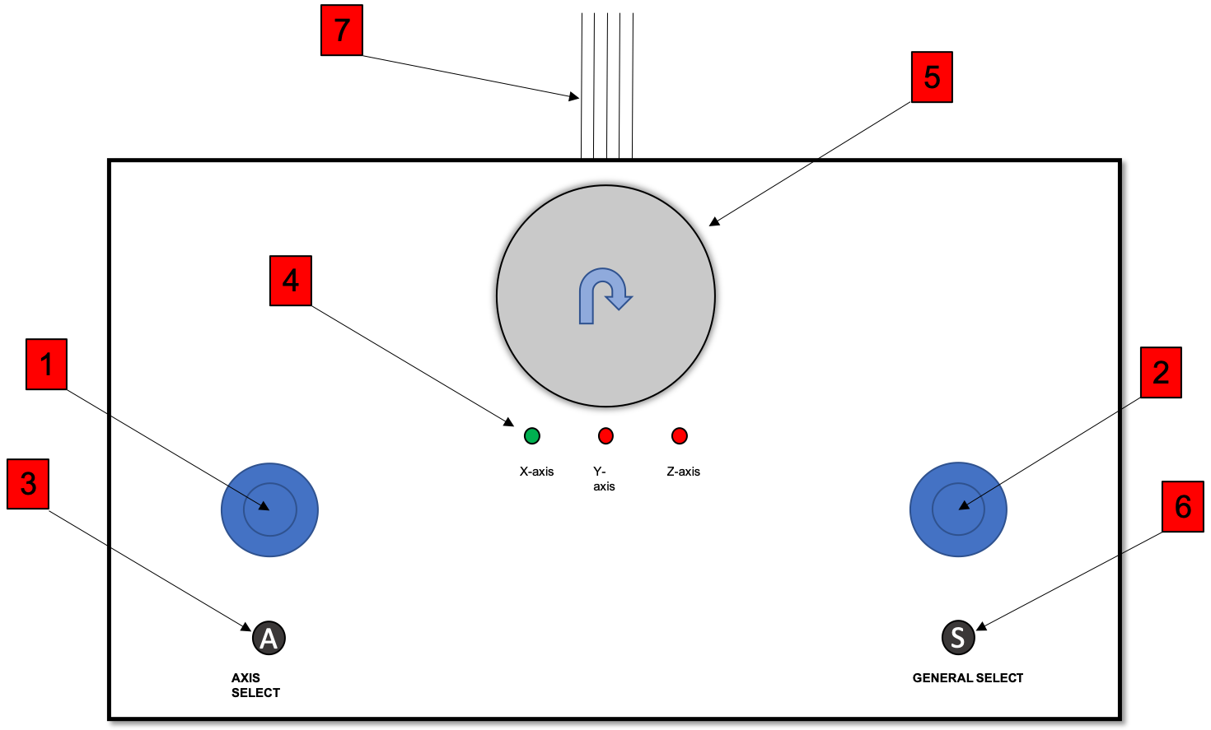

The controller hardware interface consists of 7 main parts:

1. Left Joystick - this joystick manipulates the VR object in the x-y plane of the 3-D space.
2. Right Joystick - this joystick moves the VR object on the z-axis.
3. This button serves to toggle the selected access to rotate the object about using the potentiometer dial.
4. These LED’s were intended to be used for showing the user which access is selected for rotation, but was purely for debugging, and therefore has not been included in the final fabrication.
5. This is a potentiometer that will translate rotation of the dial into rotational position of the object, about whichever axis is selected by the axis select button.
6. This button will serve as a general select, to be used within the VR application as a means for menu selection or any other future functionality that may be implemented.
7. This is the USB cable that connects to the computer running the application.